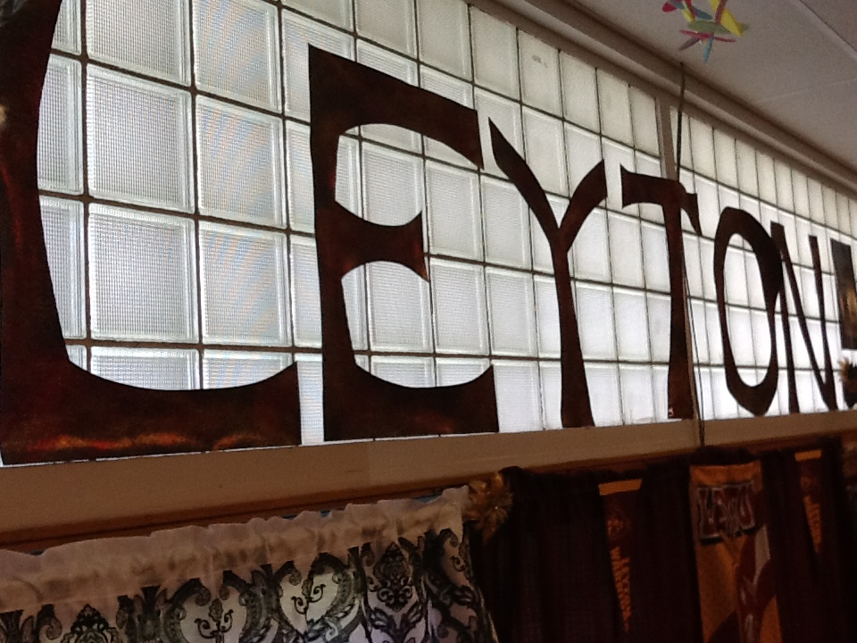

Leyton Public School Library

Research Handbook

Leyton ES/Jr. High @ Gurley: Grades K-8

Leyton HS @ Dalton: Grades 9-12

Home of the Warriors

By

Dana Morgan: [dana.morgan@leytonwarriors.org](mailto:dana.morgan@leytonwarriors.org)

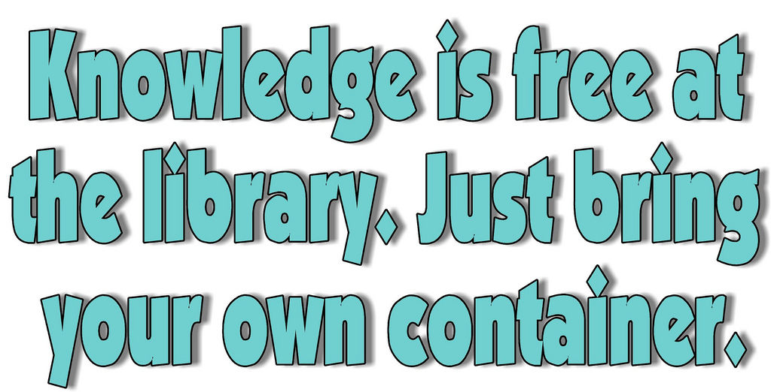

Table of Contents:

Ge

Page 3…Hours of Operation

Page 4…Leyton ES/Jr. High/Gurley Library Map

Page 5…Mission Statements

Page 6…Leyton HS/Dalton Library Map

Page 7…KWL Chart

Page 8…Research Process

Pages 9 & 10…Resource Availability and Evaluation

Pages 11 & 12…Plagiarism and Citing Sources

Page 12…Sources Referenced in Paper

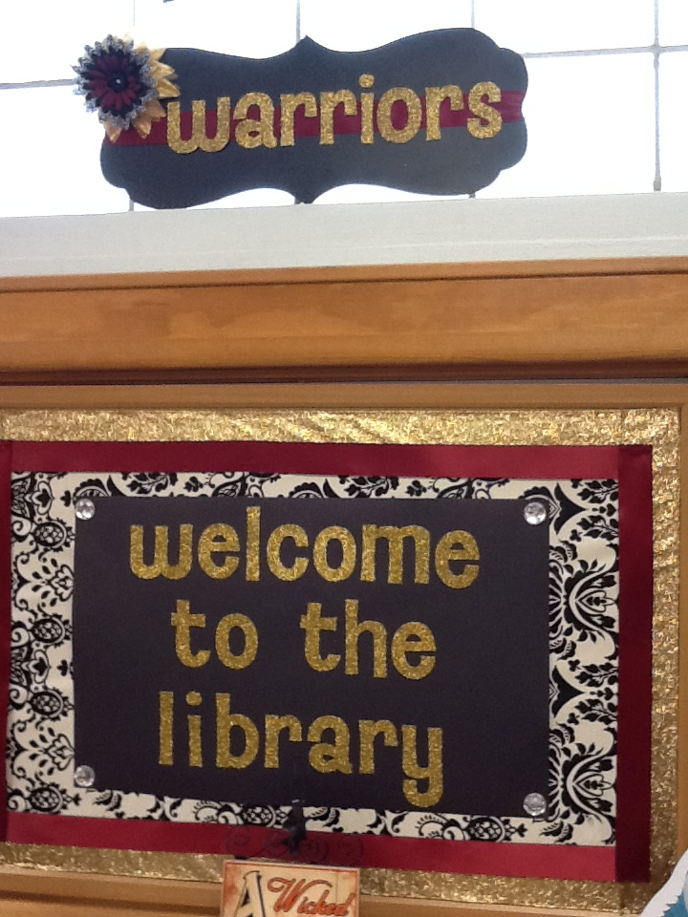

Hours of Operation:

Gurley: Monday-Friday 8:00-3:50

Dalton: Monday-Friday 7:50-3:50

*Open access during all hours!*

Leyton Elementary/Junior High School Library

Rose Street, Gurley, NE 69141

Phone: 308-884-2247

N

**Non-Fiction Books Dewey #’s 000-599**

**In & Out Door**

**Circulation Desk with Computer**

**Book Drop**

**Student Table/Seating**

**Student Table/Seating**

**Dewey 600-699**

**Biographies**  **Reference Section**

W E

**Magazine Rotating Rack**

**Dewey 700-799**

**Student Table/Seating**

**Outside Shelf (OS) Fiction E-H: Inside Shelf (IS) Easy H-O**

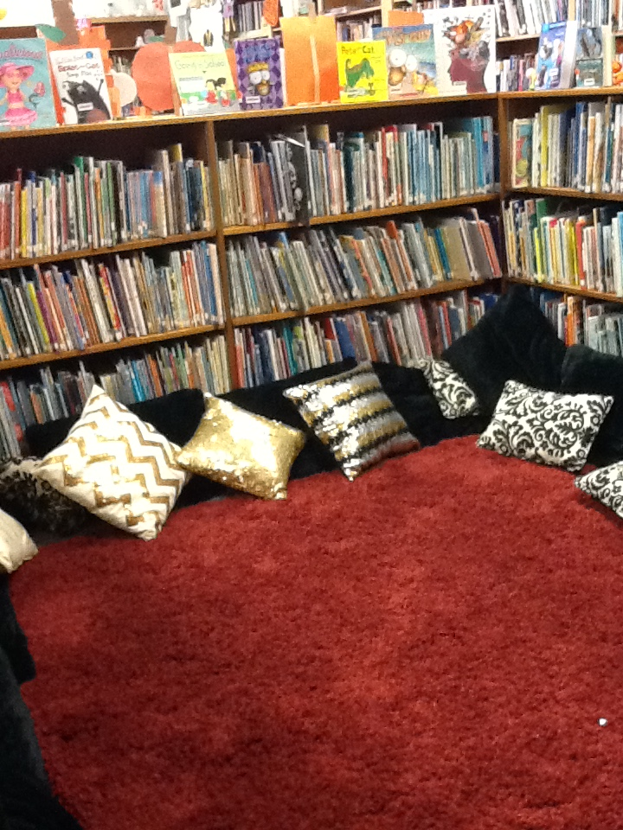

**Student Reading Area Inside Easy Section**

Mrs. Benish’s Desk

**OS Fic A-D: IS Easy P-Z**

**OS Fic I-L: IS Easy A-G**

**Dewey 800-999**

**Magazines Fiction Books Authors M-Z**

S

**Leyton Public Schools’ Mission Statement**

The mission of Leyton Public Schools is to empower and guide all students as lifelong learners by providing knowledge, opportunities, skills, and vision to make successful transitions into our diverse and changing world (Leyton, 2011).

**Leyton Public Schools’ Library Mission Statement**

The library media program is an integral part of the curriculum offered by Leyton Public Schools. The mission of the media center is to ensure that students and staff are effective users of ideas and information. The library media program seeks to provide an educational atmosphere where students are encouraged to find, evaluate, analyze, synthesize, and communicate information necessary to function in this rapidly changing world and to meet the American Association of School Librarians (AASL) Standards for the 21st-Century Learner. The media center will provide intellectual and physical access to the resources required for quality learning experiences, curriculum support, and the empowerment of lifelong learning skills (Leyton, 2011).

The AASL Standards for the 21st-Century Learner (2007) are to use in conjunction with collaboration projects, curriculum support, and provide quality learning experiences as stated in our library mission statement.

Learners use skills, resources, and tools to:

1. Inquire, think critically, and gain knowledge.

2. Draw conclusions, make informed decisions, apply knowledge to new situations, and create new knowledge.

3. Share knowledge and participate ethically and productively as members of our democratic society.

4. Pursue personal and aesthetic growth.

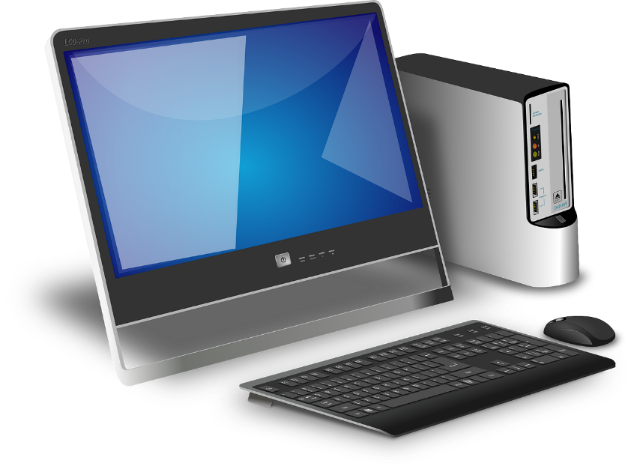

Leyton High School Library

**Fiction Continued**

**Mrs. Morgan’s**

**Office**

**Come on In ☺**

**E Books**

**4 Windows Along West Wall - In Between 2 Windows Furthest North is a Large Bulletin Board**

Main Street, Dalton, NE 69131

Phone: 308-377-2301

 

**Computer Station**



**Non-Fiction**

**Fiction**

**Student Seating Area**

**Student Seating Area**

**Copy**

**Machine**

**Biographies**

**Reference Section Between In and Out Doors**

**Non-Fiction**

**Magazine Rack**

**Non-Fiction**

**Non-Fiction**

**Fiction Books Beginning at A: Continue Down this wall…**

**Desk & Book Drop**

**Computer & Circulation Desk**

Name: ___________________________________________ Date: ____________________

Print off (page 7) and complete the organizer below before you begin your research. Keep it with you to use for notes, etc. Don’t forget to write down the titles of books or URL addresses in the L (learned) column when you locate new information for giving credit to your sources.

KWL Graphic Organizer for Research

Topic for Research: ______________________________

|  |  |  |
| --- | --- | --- |
| **What You Know** | **What You Want to Know** | **What You Learned** |
|  |  |  |
|  |  |  |
|  |  |  |
|  |  |  |
|  |  |  |
|  |  |  |
|  |  |  |
|  |  |  |
|  |  |  |
|  |  |  |
|  |  |  |
|  |  |  |

*KWL originally created by Donna Ogle, adapted for use by Dana Morgan to use with virtual handbook.*

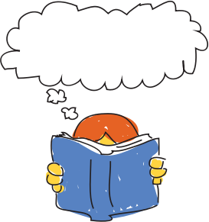**Research Process**

What to do 1st?

* Get your topic.
* Print the KWL chart to assist you with the research process.
* Fill in what you already know and want to know about your topic.
* On the back of the chart, make a list of teacher requirements.

- - - - - - - - - - - - - - - - - - - - - - - - - - - - - - - - - - - - - - - - - - - - - - - - - - - - - - - - - - - - - - - - - - -

**Now What?** 

* Start the search for materials.
* Use your library Follett Destiny resource to check out printed

materials in the library.

* Don’t forget to look in the Reference section!
* Next, try online sources-ask your librarian for **HELP** if needed!
* Make sure you know how many and what types of resources your teacher is requiring.

- - - - - - - - - - - - - - - - - - - - - - - - - - - - - - - - - - - - - - - - - - - - - - - - - - - - - - - - - - - - - - - - - - -

**Get Organized** 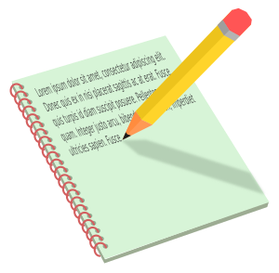

* Use the KWL to document what you **LEARNED** from both printed and online resources.
* Make notes
* Create an outline
* Ask for help if needed
* Get proofreaders involved in the process
* Always give credit for any work that is **NOT** your own.

Resource Availability and Evaluation

* 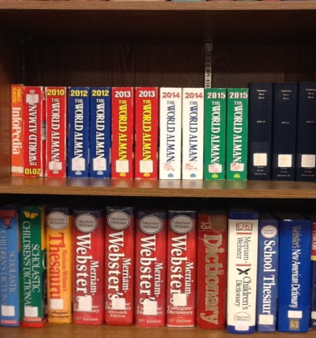The 1st place to check out for printed reference material is our reference section. Please refer to the maps of both schools to determine where our reference section is, if you are not familiar with this already. The reference section is where we keep the most **up-to-date** almanacs, atlases, dictionaries, biographical dictionaries, geographical dictionaries, one set of World Book Encyclopedias, and thesauri.
* Next, you will want to visit our online book catalog to search for non-fiction material to assist you with your research needs. You may access it here: <https://leytonwarriors.follettdestiny.com/common/welcome.jsp?context=saas57_2600184>
* Once you click on the link, just put your mouse on Leyton Public School and select to access our catalog. You may search by keyword, title, author, or subject. Once you have found books about your topic, check to see if the information is what you need according to **interest level**, **reading level**, **publication date**, **relevancy to your** project, etc. This is all provided for you through the online catalog and alleviates time consuming evaluation steps.
* Use a note card provided on the circulation desk to write down your Dewey Decimal numbers to help locate your items. If you need help, ask Mrs. Morgan or Mrs. Benish! We are here for you!
* Do you need a periodical for a source? We have numerous magazines, *USA Today, Omaha World Herald, Sidney Sun Telegraph,* and the *Bridgeport News Blade.* If you would like to use the *Reader’s Periodical Guide* to find a specific subject, please use the most current edition found in our reference section. Once you have found your topic, check with the librarians to see if we have the magazine your article can be found in. We have 27 magazine subscriptions in Dalton and 12 magazine subscriptions in Gurley. We also have older copies of magazines that are no longer in print but still contain articles about various historic events.

**Online Resources Available**

***(These sources are made available through our educational service unit. Once you click on the link, you may personalize the site to specific learning required. For example, when you go to World Book Online, click on kids, student, advanced, etc.)***

* <http://search.ebscohost.com/login.aspx?authtype=ip,uid&group=main>

Ebsco Search Engine

User name = leyton

Password = warriors

* <http://www.worldbookonline.com/wb/products?ed=all&gr=Welcome+Leyton+School+District+3%21>

World Book Online

* <http://nebraskaccess.ne.gov/>

Nebraska Access Database = available to Nebraska residents

* <http://net.pbslearningmedia.org/>

PBS Learning Media, Virtual Learning Library

**Are other sources available?**

There is an unlimited amount of information available at the touch of a mouse. The ones provided in this handbook have been selected for students by our educational service unit or by the librarians. In other words, you won’t have to evaluate them as in depth to determine if they are credible sources. This has already been done for you. You only have to decide if the sources you found contain information pertinent to your topic and are acceptable to your teacher. If you do decide to venture into other searches, please remember that domains that end in .com are full of ads. Domains that end in .edu are sponsored by schools or universities. Domains that end in .gov are government sponsored sites.

Also, remember, if you are searching for sources at school and our filters block your search, chances are that information found on that site is inappropriate or is not secure.

Please check with your teacher to see if Wikipedia is acceptable as a source. Most teachers will not allow students to use this site due to the fact that anyone can edit the information found on Wikipedia pages.

**\*\*\*If in doubt about a source, remember your librarians are here to help you, so please don’t hesitate to ask us. We can’t wait to share what we know with you.\*\*\***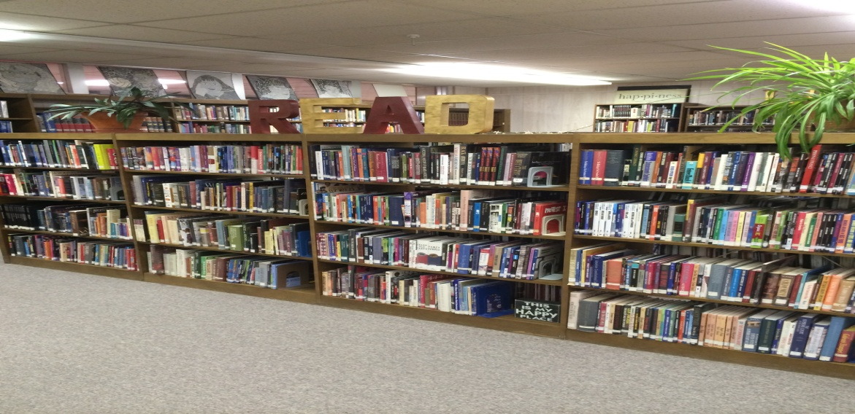

**Plagiarism and Citing Sources**

**Plagiarism=stealing, copying, cheating, illegal use, breach of copyright, piracy, fraud**

* In other words, plagiarism is against the law! You can’t borrow or copy and paste someone else’s words and use them as your own. You must give credit to the original author for their thoughts, ideas, and written words.
* My rule to remember is: When **someone else** writes it, you have to **cite** it!
* Does it matter if I only use a few words? Yes, it does. It only takes a total of **FIVE** words in a row to constitute plagiarism.
* Plagiarism can be avoided by giving credit to the original creator of the material through a reference page, a works cited page, a sources page, or a bibliography. It can be done in various formats as well. Some educators require APA and some require MLA. It is up to each individual teacher what they prefer and how they want your page to be titled. Please get specific requirements so that your work will be in the correct format.
* One other very important note is in regards to Self-Plagiarism. This “refers to the practice of presenting one’s own previously published work as though it were new” (APA, 2010, p. 170). If you used it for a paper in one class, you cannot turn it into another class as a new paper.

----------------------------------------------------------------------------------------------------------------

**Examples:**

Go back to **page 5** in this handbook. You will see that after the Leyton Public Schools’ Mission Statement, I have **(Leyton, 2011)** following the sentence. I did not write these words. They were not my original idea. They were created by the Leyton administration and board of education and are printed in the Leyton Handbook for students and staff at the beginning of every school year. When you go to my sources at the end of the handbook, you will see that I gave credit to Leyton for this. The way it is documented (author, publication date), as well as the sources at the end of this handbook, are all in APA format.

I also referenced work from the AASL on **page 5**. Please take note of the author and date. It is also standard to give the page number if that is known or when words are specifically quoted. This can be seen on this page, **page 11** following the definition of self-plagiarism.

For APA, you will need the following information for a printed source:

Author’s last name, initial of 1st name, initial of middle name if provided, date of publication, title of book, edition number if given, city of publication, state if indicated, publication company, page numbers.

The same information is required from online sources, along with a retrieval date from the web address.

For MLA, you should list the author’s name and page number for in-text citations. The difference for citing sources at the end will be the author’s last name, entire first name, title of book, the city it was published in, publisher, and then date.

***(All of the reference resources provided through our educational service unit also contain how to cite the source you are using in each individual format.)***

Many teachers allow you to use the following websites to help cite your sources:

<http://www.easybib.com/>

<https://owl.english.purdue.edu/owl/section/2/>

**Finally, if you have any questions or need any help, please ask your librarians. We are here to help and are always happy to assist you!**

Sources

American Association of School Librarians. (2007). *Standards for the 21st century learner.*

Chicago: American Library Association.

American Psychological Association. (2010). *Publication manual of the American*

*psychological association,* (6th ed.). Washington DC: American Psychological Association.

Creative Commons clip art retrieved July 2016 from: <https://search.creativecommons.org/>

Easy Bib free Bibliography Generator accessed at <http://www.easybib.com/>

Leyton Administration and Board of Education. (2011). *Handbook of information for students*

*and parents.*

Ogle, D. (1986). Creator of KWL.

OWL Purdue Online Writing Lab, accessed at <https://owl.english.purdue.edu/owl/section/2/>